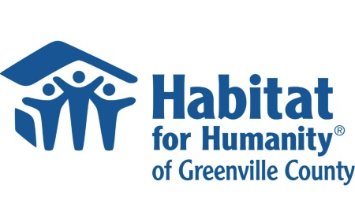

January 21, 2025

**Contact:**

Yolanda Campusano-Pilarte,

Public Relations Manager

864.320.5034

[ycampusano@miraclehill.org](mailto:ycampusano@miraclehill.org)

***A collaboration to benefit the community: Miracle Hill Ministries to repurpose Habitat Restores***

GREENVILLE, S.C. –  Two long-standing and respected Upstate nonprofits have reached an agreement that benefits the greater community and each other.

Miracle Hill Ministries will be taking over and rebranding the two Habitat Restore locations in Greenville later this month. This agreement marks a collaboration between Habitat for Humanity of Greenville County and Miracle Hill Ministries that elevates their brands and strengthens their mission to serve the community.

Miracle Hill, the largest provider of homeless services for children and adults in the Upstate, has been exploring and pursuing new opportunities to expand its operation for some time. Per the agreement, the Restores at 3303 Wade Hampton Boulevard and 1818 Woodruff Road will be reopened as Miracle Hill Thrift Stores in the coming months. To staff these locations Miracle Hill will interview internally and externally, prioritizing current Restore employees.

The Woodruff site will start selling off its surplus merchandise immediately, and the Wade Hampton site will start soon after. More information on this timeline can be found at [www.habitatgreenville.org](http://www.habitatgreenville.org).

LaTonya Phillips, the CEO and President of Habitat Greenville, said the homeownership advocacy agency had realized running a retail operation within the footprint historically used no longer matched its mission, but rather than shutting down these locations, looked for a partner. Habitat Greenville may create smaller locations or other versions of a Restore in the future.

“This move allows us to do what we do best and that is focusing directly on home building and home repair,” Phillips said.

Ryan Duerk, President and CEO of Miracle Hill said, "This change provides an amazing opportunity to share the mission and ministry of Miracle Hill with more people, while additionally supporting the operations of a partner non-profit. This helps not only both organizations but will work to help the Upstate have a stronger and more focused community of service moving forward.”

**About Miracle Hill Ministries**

Miracle Hill Ministries is the Upstate’s largest, most comprehensive provider of services to homeless children and adults.  Serving the Upstate since 1937, Miracle Hill’s programs include rescue shelters for the homeless, residential addiction recovery, transitional housing, and foster care.  Miracle Hill’s nine current  thrift stores provide employment opportunities for the community as well as former Miracle Hill guests.  For more information about Miracle Hill, please visit [www.MiracleHill.org](http://www.miraclehill.org) or call 864.268.4357.   Find us on [Facebook](https://www.facebook.com/MiracleHill/), LinkedIn, and [Instagram](https://www.instagram.com/miraclehillministries/).

**About Habitat for Humanity of Greenville County:**

Habitat for Humanity of Greenville County opened its doors in 1985 to bring families, community partners, and volunteers together to construct affordable, energy-efficient homes that help families build strength, stability, and self-reliance. As of December 2024, Habitat Greenville has completed the construction of more than 420 homes. Learn more at [www.habitatgreenville.org](http://www.habitatgreenville.org/).