Contact: Yolanda Campusano, Communications & Public Relations
FOR IMMEDIATE RELEASE

864.631.0146 or 864.320.5034 (cell)
ycampusano@miraclehill.org

Miracle Hill Ministries Opens Emergency Cold Weather Shelter
Greenville, SC. October 30, 2022- As part of Miracle Hill Ministries’ commitment to the community, our adult shelters have started providing emergency cold weather shelter for the 2023 Fall/Winter season. Our Rescue Missions offer this service on nights when the predicted outside overnight temperature is expected to fall to 40 degrees or lower (clear nights), or 43 degrees or lower with 60 percent or greater chance of precipitation.

Our cold weather shelters offer 200+ additional beds for men and women with children experiencing homelessness:
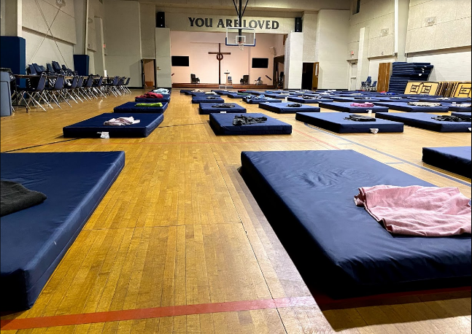
- Greenville Rescue Mission = Men only.
- Shepherd’s Gate = Women and Mothers with young children.
- Spartanburg and Cherokee County Rescue Missions = Men, Women, and Mothers with children.
A white flag is flown on the flagpole of the Rescue Missions whenever the cold weather shelter is open. To enter, guests begin checking in at 8:00 p.m. at which time they are given the opportunity to shower, given a snack or meal, and are assigned a mat and blanket. Guests who conduct themselves in an orderly manner are allowed to stay, and they will receive a breakfast item and coffee at check out at 6:30 a.m.

****
ABOUT MIRACLE HILL MINISTRIES
Miracle Hill Ministries is the Upstate’s largest, most comprehensive provider of services to homeless children and adults. Serving the Upstate since 1937, Miracle Hill’s programs include rescue shelters for the homeless, residential addiction recovery, transitional housing, and foster care. Miracle Hill’s eight thrift stores provide employment opportunities for the community as well as former Miracle Hill guests. Miracle Hill has been awarded the Certificate of Excellence as a Certified Mission by City Gate Network, a distinction given to fewer than 30 missions nationwide. Additionally, Miracle Hill’s foster care program has been accredited by CARF International. For more information about Miracle Hill, please visit www.MiracleHill.org or call 864.268.4357. Find us on Facebook, LinkedIn, and Instagram.

