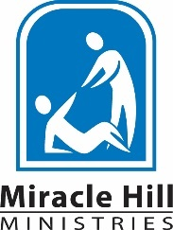
FOR IMMEDIATE RELEASE
Contacts:
Yolanda Campusano-Pilarte,
Public Relations Manager
864.320.5034
ycampusano@miraclehill.org

Candace Fritz,
Event Coordinator
864.631.0148
cfritz@miraclehill.org

Miracle Hill’s Kids Ninja Challenge:
Connecting Children with the Needs of our Community

GREENVILLE, SC (July 21, 2023) – As the largest provider of homeless services in the Upstate, Miracle Hill is always innovating and looking for ways to better engage with the community. The Kids Ninja Challenge is a summer event designed to teach children how to care for the homeless population by fundraising for the ministry’s programs and facilities.
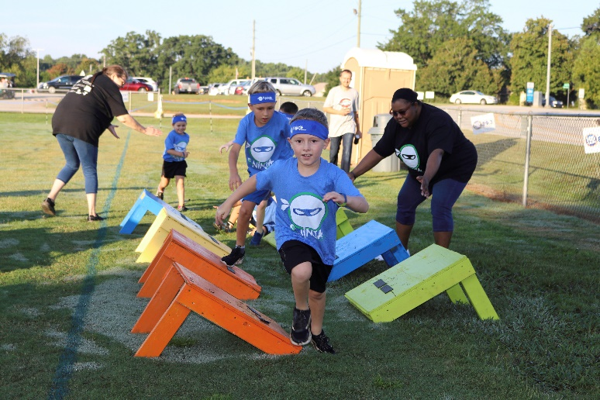
Miracle Hill’s Annual Kids Ninja Challenge is a family-friendly fundraising event for children ages 4 to 12. Kids are given the opportunity to become a ninja for the day and challenge themselves to 15+ obstacles (wet and dry). “Children get to have fun and exercise, while parents enjoy family time and support the community. This is a win-win, you can’t miss this opportunity!”, said Candace Fritz, Miracle Hill’s Event Coordinator.

The event will take place at the YMCA Program Center in Simpsonville, on Saturday, August 12, 2023. When your child registers for the event, an online fundraising page will be created for them. There will be fundraising prizes at various levels and special prizes for top fundraisers! During the event there will be water slides, bounce houses, face painting, and music, all included with registration.

For more information or to donate in support of Miracle Hill’s shelters and programs, visit miraclehill.org/ninja.

-more-

About Miracle Hill Ministries
Miracle Hill Ministries is the Upstate’s largest, most comprehensive provider of services to homeless children and adults. Serving the Upstate since 1937, Miracle Hill’s programs include rescue shelters for the homeless, residential addiction recovery, transitional housing, and foster care. Miracle Hill’s eight thrift stores provide employment opportunities for the community as well as former Miracle Hill guests. Miracle Hill has been awarded the Certificate of Excellence as a Certified Mission by City Gate Network, a distinction given to fewer than 30 missions nationwide. Additionally, Miracle Hill’s children’s program has been accredited by CARF International. For more information about Miracle Hill, please visit www.MiracleHill.org or call 864.268.4357. Find us on Facebook, LinkedIn, and Instagram.

###

